الاسم :___________ المبحث : اللغة الانجليزية

وزارة التربية والتعليم
مديرية التربية والتعليم / منطقة السلط
مدرسة الصوانية الاساسية المختلطة
امتحان تشخيصي/الفصل الاول
لعام 2025/2026

الصف: الخامس التاريخ : / /2025

مدة الامتحان : حصة واحدة

******************************************************************
Q.1 Read the text and answer the following questions: ( / 5)
We must plant more trees. Trees are very important.
Trees are home for many animals and birds.
They clean the air. Trees give us wood and paper.
Every year on 15th January, children plant trees.
It is an important day. We sing song, we take photos
and make videos. We watch the trees grow.

- What do trees give us? ________________________
- Children watch the trees grow . T F
- Every year ( 15th January / 15th March) children plant trees.
- Children ( sing / plant ) songs .
- Find out from the text:
- An adjective: ______________
- A plural noun: _____________
Q.2 Fill in the blanks with the correct word from the box: ( /5)

village postcards squirrel sewed warm
- It’s going to be ___________ on the farm.
- My grandma didn’t live in a city. She lived in a ____________.
- The women ___________ beautiful clothes last month.
- Mum is buying some _____________.
5-The ___________ is a small animal.
Q.3 Choose the correct answer: ( / 8)
1. I am ________ than my brother.
a- taller b- tall c- tallest

2.The planetarium is the ___________room in the museum.

a- dark b- darkest c- darker

3. __________ can you see in the museum?

a- When b- Where c- What

4. In the past, this street _________ a river.
a- was b- were c- didn’t

5. Maha is _______ her teeth now.
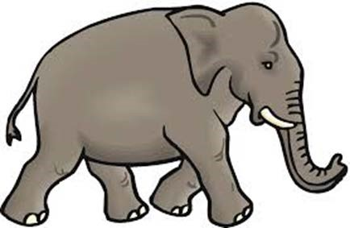
a- brush b- brushed c-brushing

6- The missing letters in ele ___ ant are:

a- f b- ph c- gh

7- You don’t have to _______ the plant every day in winter.
a- water b- watered c- waters

8- One of the following sentences is punctuated correctly:
a- kareem and Samira. b- Kareem and samira. c- Kareem and Samira.

Q.4 Answer the questions about you : ( / 2 )

1.What did you do last week? ______________________________

2.What do you do on Friday? ______________________________

GOOD LUCK

