3rd grade Work sheet Name:
--------------------------‐-------------------------------------------------------------------------------------------------------

Q1. Read and answer the questions bellow:
In the attic, I'm Omar this is the attic in my home . There's an armchair behind the bookcase . There aren't any books on the bookcase. There are toys .
A)Find out : 1)noun: 2) preposition :
B:1). Omar is on the..... a)bedroom. B) attic. C) garage
2)The armchair is ....the bookcase. A) opposite. B) behind. C) next to
3)..….. any books on the bookcase. A) There are. B) There aren't
4).....a sofa in the attic A) There isn't. B) There's
……………………………………………………………………………………………………………………………………………………………………
2) listen and circle (:
1) (There is/There are) a sofa. 2) ( There is/There are) a door
3)(There is/There are) armchairs. 4)(There is/There are) windows
5)(There is/There are) clock. 6)(There is/There are) mirrors.
................................................................................................
3. Circle the correct answer :
- He ………………………………. A big house. ( have got / has got )

- We ……………………………………… dirty pets . ( hasn’t got / haven’t got )

- You ………………………………… a hard ball. ( has got / have got )

- I ……………………………… a new drees. ( haven’t got / hasn’t got )
.........................................................................

4: Listen and write {cl._ Fl. _ Sh. _ Sl. }

- ………ug. 2)……….ean. . 3) ………..eep. 4)……..ag
5 )fi……..
5: Match :

[ Wardrobe _Armchair _Television _ Book case [

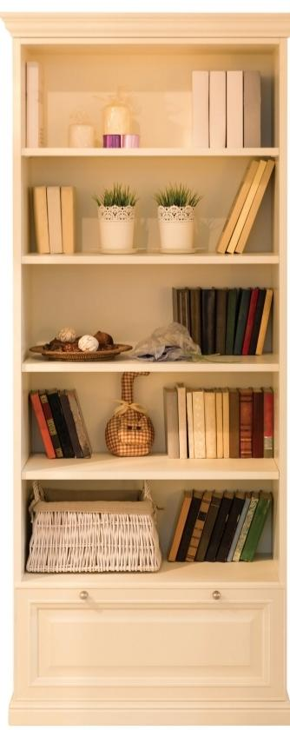
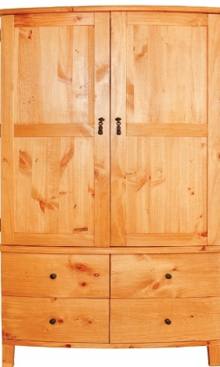
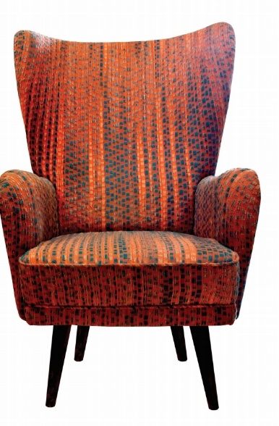


..............................................................................,.
Best wishes
Miss Wegdan ️

